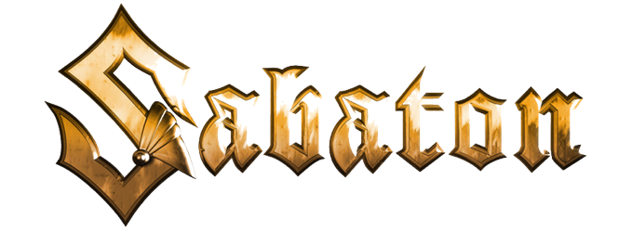

***The War to End All Wars***

**"Race to the Sea"**

**Music:**  Joakim Brodén

**Lyrics:** Joakim Brodén

We’re keeping the kingdom free

As an archduke falls and the battle horn calls, our lives would never be the same

We were looking down barrel of a gun

Now the war has come and the battle has begun, we are desperate and overrun

To the war drum we’ll be marching until it’s done

Lead the way, we will follow into the fray

We will hold the line we will not be led astray

For king and for country we, are flooding the river

Our stand at Yser will be, the end of the race to the sea

The last piece of Belgium is free, we’re keeping a sliver

A cog in the war machine, October of 1914

As our foe draws forth we are moving on north we will never let them have it all

There’s a price for freedom paid by Belgium's sons

They may take our towns, they may conquer our grounds we’ll defend the nation and the crown.

We’ll uphold our independence with our guns

All the way, on to triumph or to judgement day

We will follow and we will not be led astray

See a king and a soldier, fighting shoulder to shoulder

See a king and a soldier, fighting shoulder to shoulder

He overruled his commanders, he made a last stand in Flanders

We see our king and a soldier, they’re fighting shoulder to shoulder

To keep the last piece of Belgium free

All the way, on to triumph or to judgement day

We will follow and we will not be led astray

For King and for country we are flooding the river

Our stand at Yser will be, the end of the race to the sea

We’re free

For King and for country we are flooding the river

No more of our country lost, the line will be held at all cost