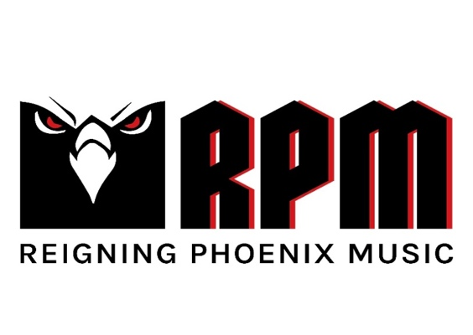

FOR IMMEDIATE RELEASE

MUSIC INDUSTRY EXECUTIVE GERARDO MARTINEZ,
AND AVIONICS AND TECH ENTREPRENEUR SVEN BOGNER,
ANNOUNCE THEIR PARTNERSHIP IN NEW RECORD LABEL,
REIGNING PHOENIX MUSIC (RPM)

LOS ANGELES, CA – HAMBERG, GERMANY – Monday, July 17, 2023 — Today, an unlikely duo comprised of music industry leader Gerardo Martinez, together with avionics and tech entrepreneur Sven Bogner, announce their partnership in a new record label, Reigning Phoenix Music (RPM).

Martinez, Nuclear Blast America’s former long-time General Manager, brings his two-decades-plus label experience and successes to the new venture, having signed and worked closely with Slayer for several years, as well as having been instrumental in the careers of Dimmu Borgir, Carcass, Hypocrisy, Kataklsym, Meshuggah, Machine Head, Epica, Soulfly, and many more.

In addition to being responsible for many groundbreaking technological advancements in avionics, GPS Systems, and Automotive, Sven Bogner is a lifelong, self-professed metalhead and musician. With his tremendous success in the tech world and his new partnership with Martinez, he and metal have come full circle.

“Everything I do, I do with passion and conviction,” said Bogner. “I am an entrepreneur by heart because I like to create things. Our most important goal is to help the artists amplify their art and talent to a winning formula for success. The moment I met Gerardo, I realized that we share the same spirit.”

Currently headquartered in Los Angeles and Hamberg, Germany, RPM’s main objective is to fully support localized market expertise by offering the best services and practices in the industry worldwide. Said Martinez, “Our collective blueprint for RPM is to help hard, extreme, and heavy metal music thrive globally, to partner with an array of well-established acts, new talent, and iconic artists. Sven and I share the same passion for the music and the desire to become the best in what we do for the right reasons: our artists.” RPM has already signed several iconic names in metal to the label, with official announcements imminent.

# # #

Media Contact:
Heidi Ellen Robinson-Fitzgerald
heidirobinsonfitz@icloud.com
818-705-1267

