***FOR IMMEDIATE RELEASE***

**ROCK MUSIC’S BREAKOUT BAND OF 2022**

**CLASSLESS ACT**

**TO PREMIERE SERIES OF ACOUSTIC SONGS & VIDEOS**

**FROM ACCLAIMED DEBUT *WELCOME TO THE SHOW***

**L.A. Act Is Fresh Off Appearance At Taylor Hawkins Tribute Concert**

**At Kia Forum & Just Announced New Dates in December**

**Supporting Giovannie & The Hired Guns**

**Starting Today With Stripped-Down Version Of**

**Self-Titled Track “Classless Act”**

**Culminating In A 5-Song/Video Collection December 16**

**Watch/Listen To “Classless Act” Acoustic** [**HERE**](mailto:%20https://classlessact.ffm.to/ClasslessActAcoustic)

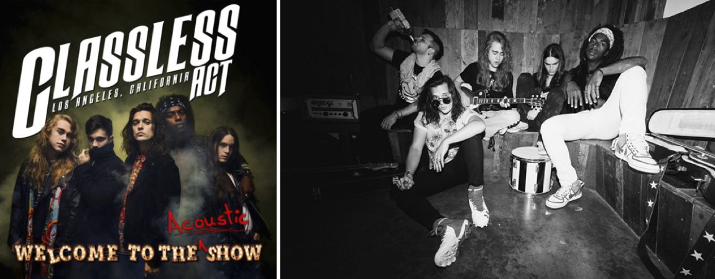

*Classless Act band photo by Travis Shinn*

**LOS ANGELES, CA - Friday, October 21, 2022 –** Rock music’s most exciting debut of 2022, **Classless Act**, are giving listeners a different, unplugged take on the amped up, energetic anthems that make up their acclaimed album, ***Welcome To The* Show,** which was released June 24 via **Better Noise Music** and has already racked up more than two-million streams.

Starting today, the L.A.-based five-piece will launch a series of acoustic versions of the record’s hit singles, beginning with the self-titled song **“Classless Act”** alongside a new video.

Hear the acoustic version of **“Classless Act”** [**HERE**](https://classlessact.ffm.to/ClasslessActAcoustic)

See the acoustic video [**HERE**](https://www.youtube.com/watch?v=lDV4Pi3xPeM)

**Classless Act** singer **Derek Day** recently appeared at the **Taylor Hawkins Tribute Concert** at L.A.’s Kia Forum on September 27 where Day joined **Dave Grohl** and members of the **Foo Fighters** as well as **Mötley Crüe** for a special two-song set. He was personally recommended for a spot on the all-star lineup by **The Darkness’ Justin Hawkins** who also appears on the **Classless Act** track, **“This Is For You.”**

In December, **Classes Act** will head out on the road again with *Billboard* chart toppers Giovanni & The Hired Guns for a U.S. tour that begins in Mobile, AL and wraps in Richmond, VA, with more dates to be announced. Tickets are on sale now at https://classlessact.com

Over the next two months, **Classless Act** will release a new acoustic take and new video every two weeks, culminating in a five-song collection, ***Welcome To The Acoustic Show****,* on **December 16**. The additional releases will include unplugged versions of **“This Is For You,” “Time To Bleed,” “All That We Are”** and **“Storm Before the Calm.”**

Recorded live at Sunset Sound, with no overdubs, the new takes hone in on the talent of frontman **Derek Day** and the musicianship of the talented-beyond-their-young-years ensemble that includes **Dane Pieper** (guitar), **Griffin Tucker** (guitar), **Franco Gravante** (bass), and **Chuck McKissock** (drums). **Gravante** personally mixed the acoustic tracks himself.

“Every song on the album pretty much started out this way. And we thought it would be cool for you to hear where we started. And we decided if we were going to do this, it needs to be LIVE; no f***ing around,” says **Derek Day**.

Upon ***Welcome To The Show’s***release on June 24, **Classless Act** immediately garnered critical acclaim with press hailing them as “the next big thing in music” **(*Next Mosh*)** and “very reminiscent of when rock reigned supreme” **(*Loudwire)*.** ***The Rock Pit*** declared the songs on the album “break like Queen used to so well into flamboyant guitar [with] Supertramp meets Muse aplomb,” and ***New Noise***also said it’s a record “that feels most easily summed up as ‘powerful’” from “a new-ish band who sound like the greatest hits of ‘70s and ‘80s rock eras, with a grace and vibe that’s more modern.”

The album reviews echoed the positive reviews the band has received for their live show, having shared the stage with **Dorothy** and **Dirty Honey** as well as an opening slot on the summer’s biggest tour, the $173.5 million grossing **Stadium Tour** that graced major stadiums across the country and Canada.

Seeing **Classless Act** live, ***Bravewords***said they “sealed their place among hard rock’s new elite.” ***Splice***affirmed, “While the band may be new, they performed liked seasoned pros. … Their music was filled with driving beats, big hooks, great guitar work and equally as important tons of rock n’ roll attitude.” And ***Dread Music***said, “**Classless Act** absolutely made their presence known as they served up high octane rock music on a platter to everyone in the park. … I was a fan before they finished their first song. This band is another in the army of acts that are the future of rock n’ roll and I have no doubt that **Classless Act** will be out there headlining their own tour soon enough.”

In addition to appearing on the **Stadium Tour** that featured Def Leppard, Joan Jett and Mötley Crüe, **Classless Act** also played **Aftershock** (October 9), the West Coast’s Biggest Rock Festival, where they shared the bill with **Muse**, **Bring Me The Horizon** and **The Struts**.

**CLASSLESS ACT SUPPORTING GIOVANNIE & THE HIRED GUNS TOUR DATES**

Dec 1 – Mobile, AL @ Soul Kitchen

Dec 2 – Destin, FL @ Club LA

Dec 7 – Orlando, FL @ House of Blues

Dec 8 – Chattanooga, TN @ Barrel House

Dec 9 – Louisville, KY @ Mercury Ballroom

Dec 10 – Johnson City, TN @ Capone’s

Dec 14 – Asbury Park, NJ @ Wonder Bar

Dec 16 – Syracuse, NY @ Lost Horizon

Dec 17 – Harrisonburg, PA @ Stage on Herr

Dec 18 – Richmond, VA @ The Broadberry

**ABOUT CLASSLESS ACT:**

It’s not often that a band comes around like Classless Act who have tempted a new generation of fans and given rock’s faithful a reason to keep believing. Influenced by **Queen**, **Led Zeppelin,** **The Beatles** and **Bowie**, the L.A.-based five-piece bring a fresh, young take on a golden age of music. They’ve been applauded by bands like Jane’s Addiction, given nods from execs with Live Nation and MTV, and are already finding their footing in major international markets barely a year after releasing their first single “Give It To Me” in 2021.

With the release of their anticipated debut *Welcome To The Show* via Better Noise Music on June 24, the band immediately racked up two-million streams and got the attention of rock bibles like ***Loudwire****,* ***SPIN****,* ***Metal Hammer****,* and ***Blabbermouth****,* the latter who said Classless Act *“stands ready to carve out a legacy of its own.”*

While the music tells its own story, so do the members of the band themselves, hailing from all over the globe, including Hawaii, Los Angeles, Argentina, and Dallas. The band, featuring Derek Day (vocals), Dane Pieper (guitar), Griffin Tucker (guitar), Franco Gravante (bass), and Chuck McKissock (drums), first formed in 2018 when the five former strangers met through friends via social media. Their chemistry quickly came to light, the members fusing together anthemic rhythms, shreddy guitars, soaring vocals and clever arrangements that, as one writer astutely said, have "...enough energy to power a city."

With personal invites to appear on summer 2022’s highest grossing tour, **The Stadium Tour,** as well as the **Taylor Hawkins Tribute** **Concert** and **Aftershock Festival,** Classless Act are giving the industry whiplash with the constant head turning and are poised to become a next-generation defining act.

**CONNECT WITH CLASSLESS ACT**

[Facebook](https://www.facebook.com/pages/category/Musician-Band/Classless-Act-837828273044613/) | [Twitter](https://twitter.com/ClasslessActLA) | [Instagram](https://www.instagram.com/classlessact/) | [YouTube](https://www.youtube.com/channel/UCO1ymtC1unoMyxSnGAi53cg) | [TikTok](https://www.tiktok.com/@classlessact?lang=en) | [Twitch](https://www.twitch.tv/classlessactstreams)

**ABOUT BETTER NOISE MUSIC**

BETTER NOISE MUSIC is the premiere independent music label under BETTER NOISE ENTERTAINMENT, a content creation and marketing company that produces music, books, films, documentaries, TV shows, theatrical productions, and tours. Better Noise Music (formerly Eleven Seven Music), founded in 2006 by music industry veteran and independent pioneer Allen Kovac, focuses on artist development and has grown into a music industry independent powerhouse, with a roster including Five Finger Death Punch, Asking Alexandria, Bad Wolves, Dirty Heads, Nothing More, The HU, AWOLNATION, All Good Things, From Ashes To New, Cory Marks, and Fire From The Gods. Partnering with FUGA, AMPED and Membran, the company operates a global marketing and distribution platform with offices in New York, Los Angeles, London, Berlin, Paris, Toronto and Sydney.

In 2021, Better Noise Music dominated *Billboard’s* Year End charts in the rock space, landing at #1 on the Mainstream Rock Imprint, Hard Rock Songs Imprint, Hard Rock Songs Label charts and ranked as one of the top Mainstream Rock Label for the year.

**CONNECT WITH BETTER NOISE**

[Website](http://betternoise.com/) | [Facebook](https://www.facebook.com/BetterNoiseMusic/) | [YouTube](https://www.youtube.com/c/ElevenSevenMusic/search?query=classless%20act) | [Spotify](https://open.spotify.com/user/elevensevenmusic) | [Instagram](https://www.instagram.com/betternoisemusic/) | [Twitter](https://twitter.com/betternoise) | [TikTok](https://www.tiktok.com/@betternoisemusic?lang=en)

**MEDIA CONTACTS:**

Classless Act U.S. National Media | Heidi Ellen Robinson-Fitzgerald | HERFitzgerald@outlook.com

Classless Act U.S. Tour Media | Selena Fragassi | selena@fr-pr.net

Better Noise Music | Eliana Nunez | [eliana@betternoise.com](mailto:eliana@betternoise.com)

# # #