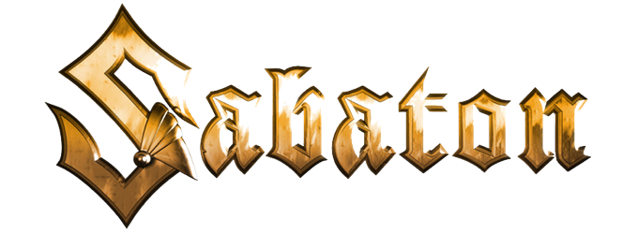

***The War to End All Wars***

**"Versailles"**

**Music:** Joakim Brodén & Chris Rörland

**Lyrics:** Pär Sundström & Joakim Brodén

The war had been raging and ravaging for 4 years, leaving millions of casualties from all sides.

In the trenches of the frontlines people have asked the question, what is the price of peace?

How many more must die?

Exactly five years after the assassination of Franz Ferdinand, Germany is forced to sign an unconditional surrender.

For the signing of this historical document, the French city of Versailles is chosen.

Signed a treaty to change the world

Tensions fall and a peace is unfurled

Nothing like what had come before

It’s the deal, it’s the treaty that will end the war!

A fragile but hopeful peace falls upon the European continent.

America returns to their shores, Russia tend to their own matters and the

British empire disbands their colonial forces.

Parades are being held in victorious countries.

The war that would end all wars is over.

But not everyone agrees. In the underground something is growing in the dark.

Because for some the war never ended.

War will never entirely die, it will evolve, it will change and War will return, sooner than we think.

From a shot that would change the world

Tensions rise and a war is unfurled

Nothing like what had come before

It’s the war that will end all war!

Will this war really end all wars?

Can a war really end all war?

Will this war bring another war?

It’s the war that will end all wars!